# K.Vanitha

**Software Installation**

## Installing Python

Follow these steps to install python in your machine.

1. Download python from <https://www.python.org/downloads/release/python-368/>. We are going to install python 3.6.8.

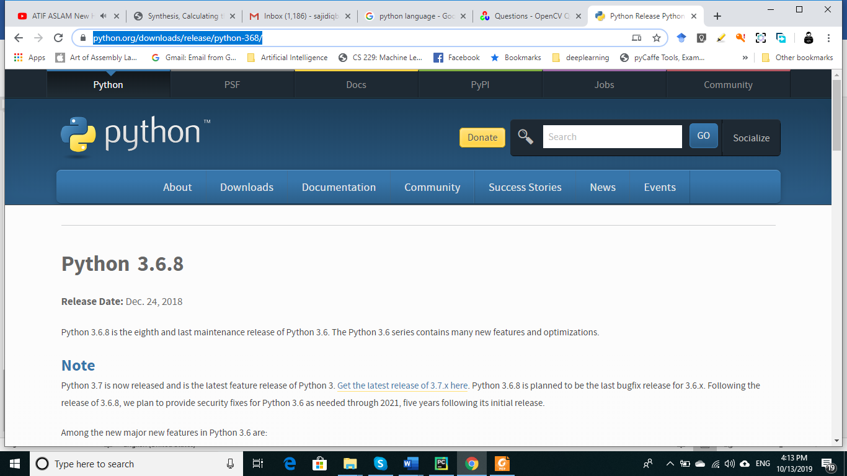

1. Scroll this down and find following item. We assume that you are using Windows 64-bit machine. If you have other machine, please select the relevant file.

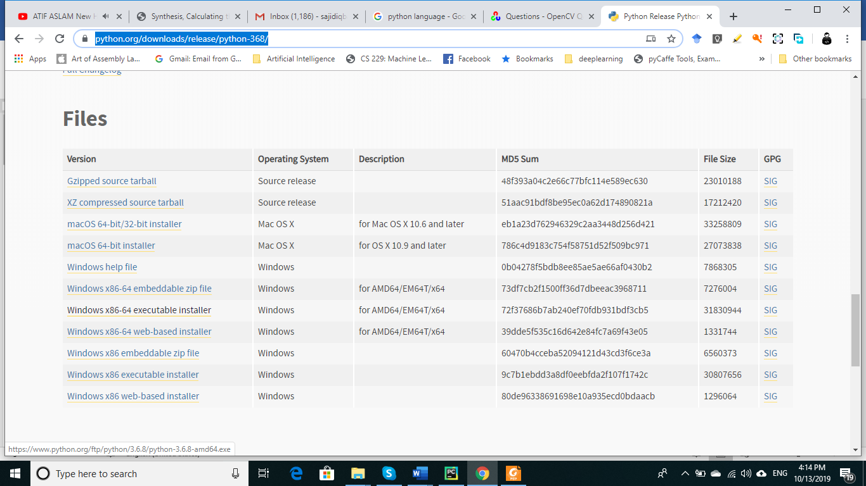

1. Download the file

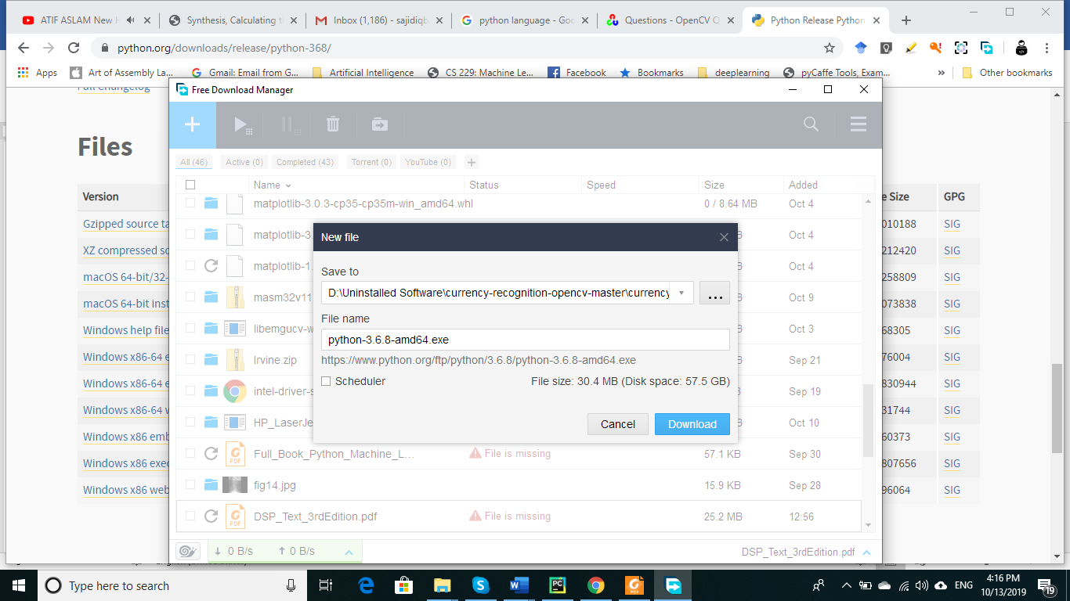

1. When file is downloaded, double click to run it. Remember to select “**Add Python 3.6 to PATH**”. Choose the path to install Python. There is no need to change the path until otherwise you have genuine reason to use other path.

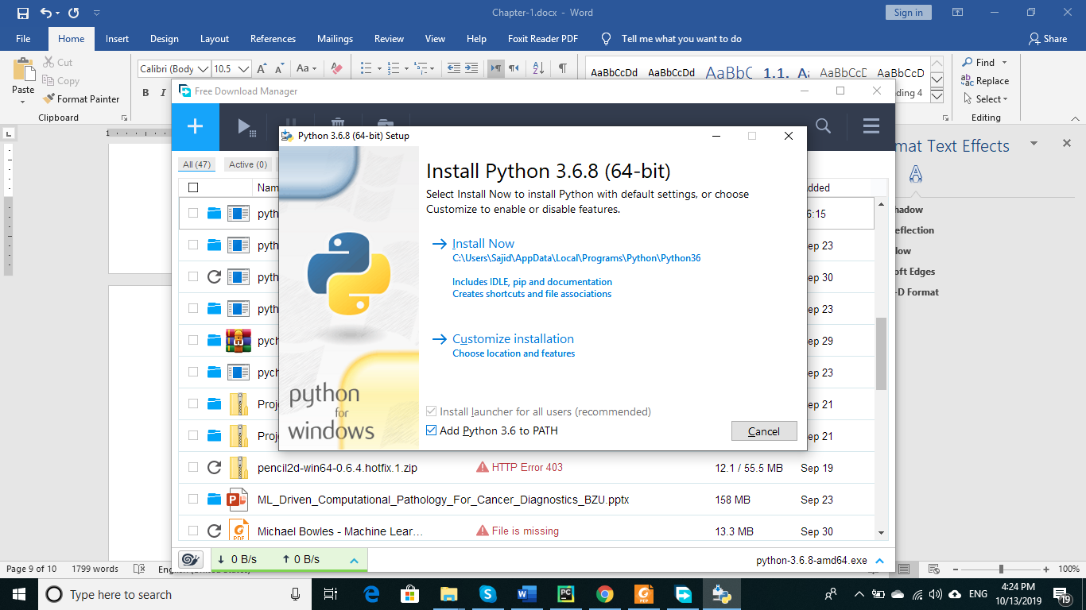

Choose the path

1. Press on “Install Now” to start installation process

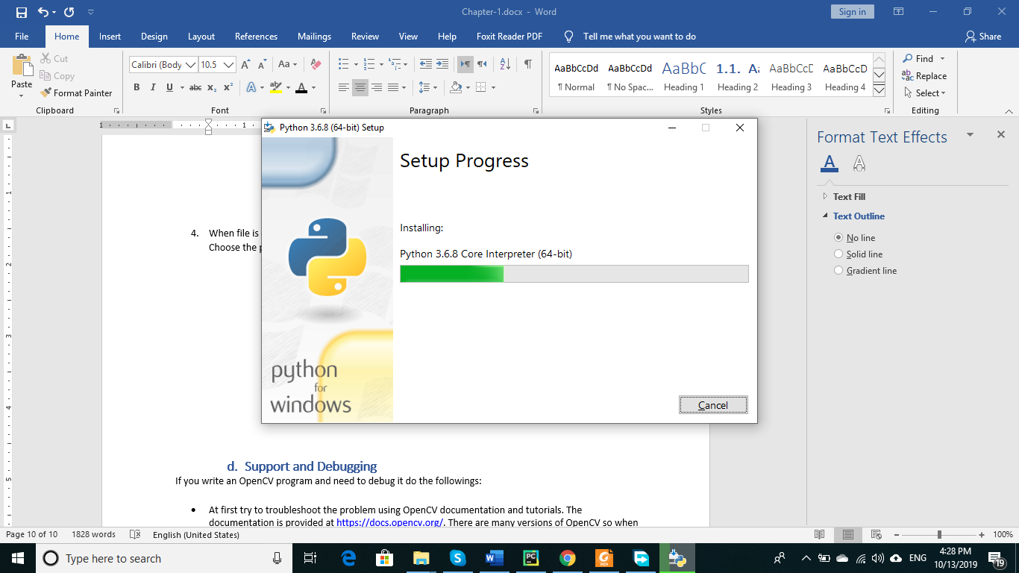

1. When the setup process completes, it shown following screen. (In case of any error, see the relevant documentation on python website or get help from Internet)

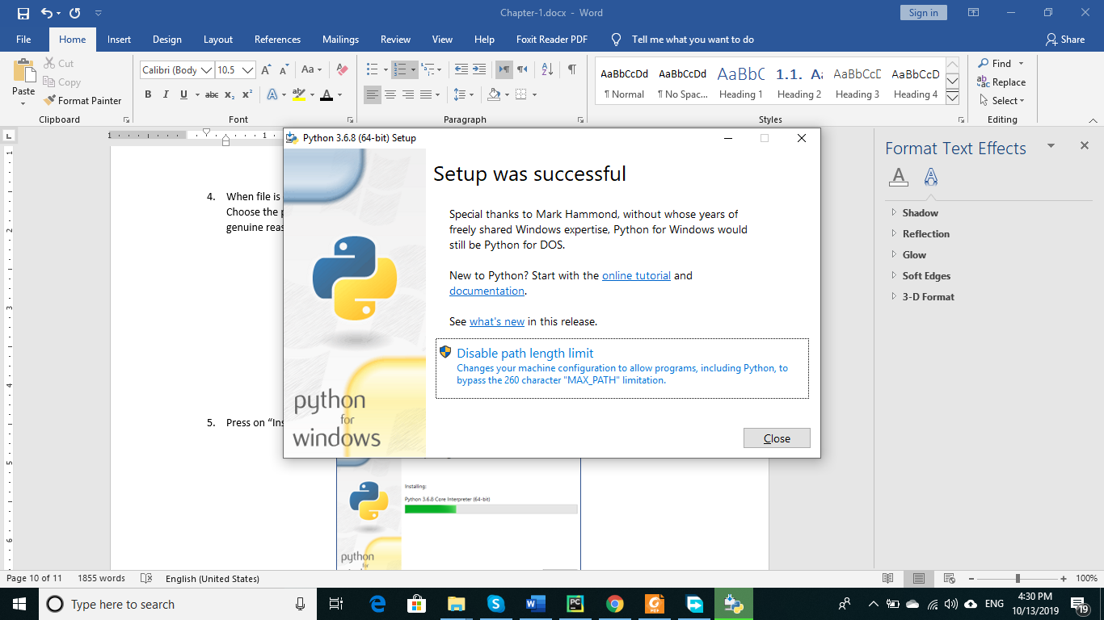

## Installing PyCharm Community Edition

Follow these steps to install your PyCharm (python development IDE).

1. Download the software from



1. Choose the community edition.

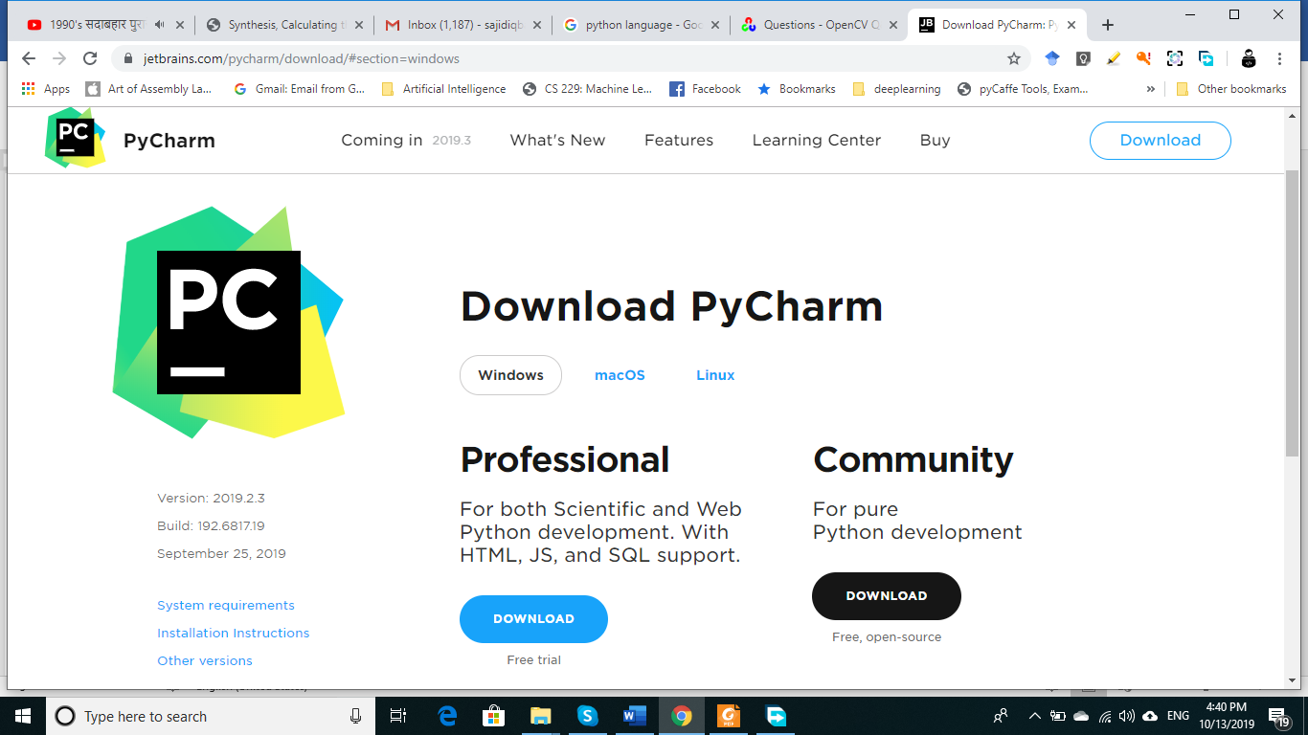

1. Download the file. The file is large in size so it may take some time to download.

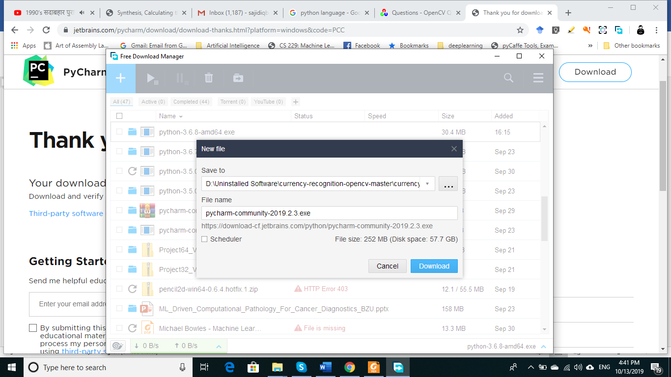

1. Double click the downloaded file to start installation.

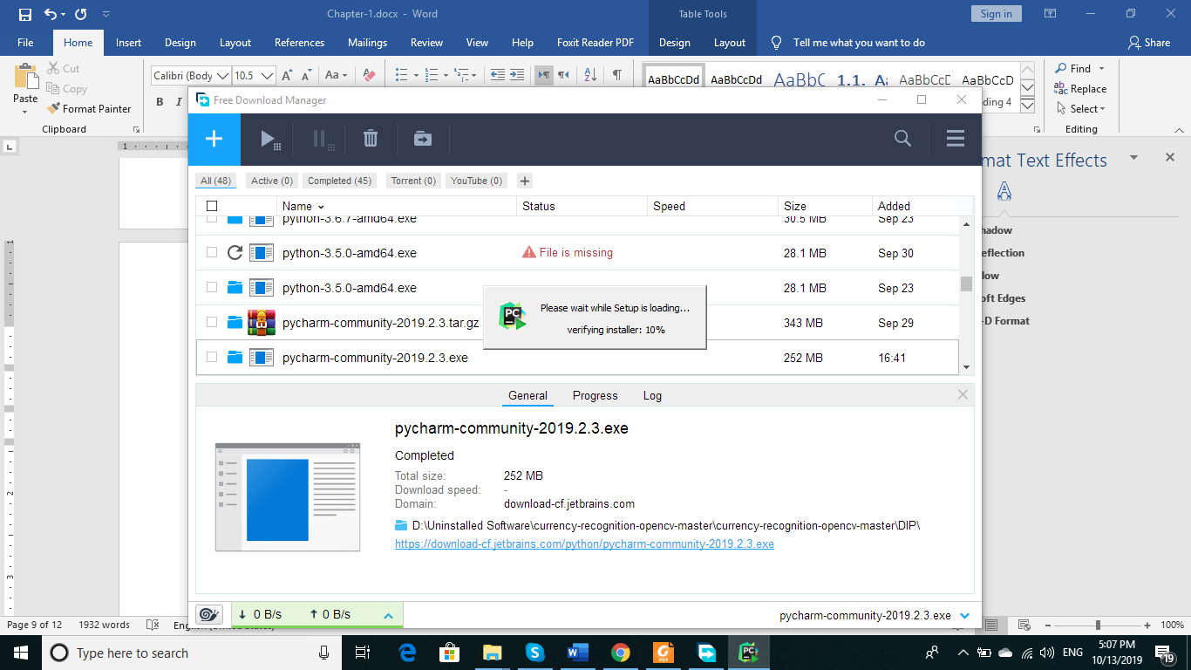

1. After setup loading, a PyCharm setup window will appear as follows. Click on “Next >”:

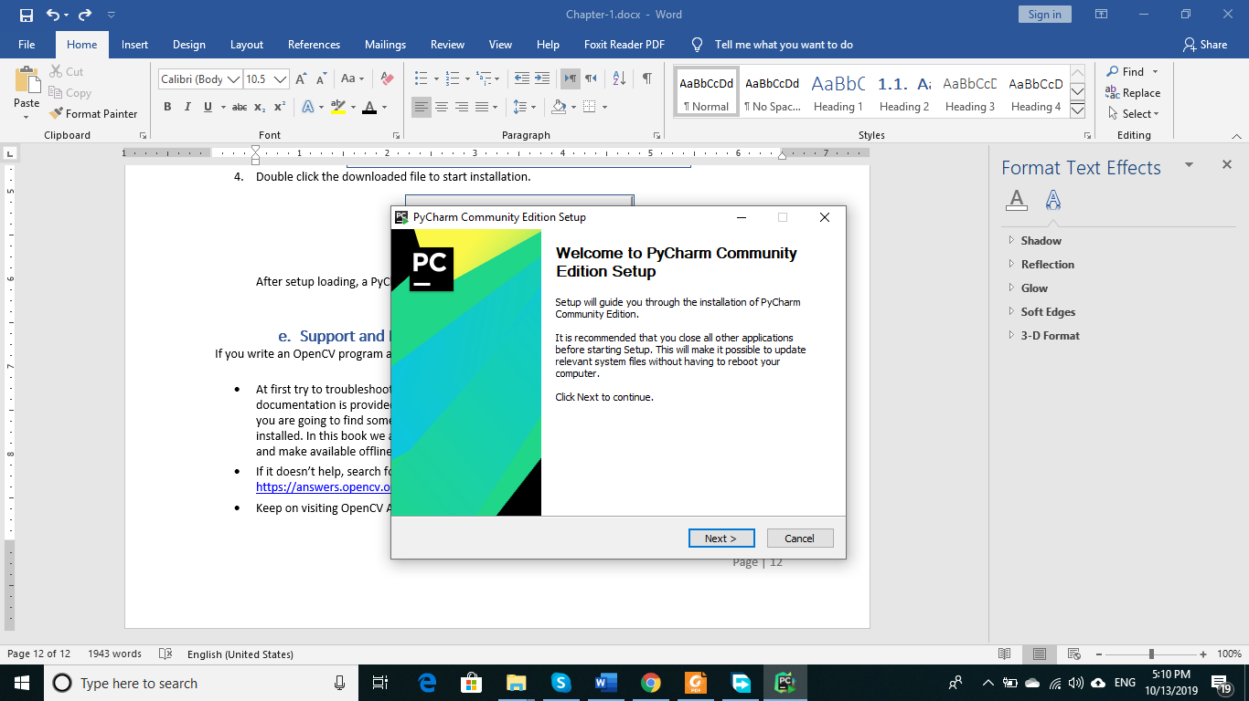

1. If you have already installed an older version of PyCharm, you can uninstall that silently from this screen too. As I have older version installed, so I see screen.

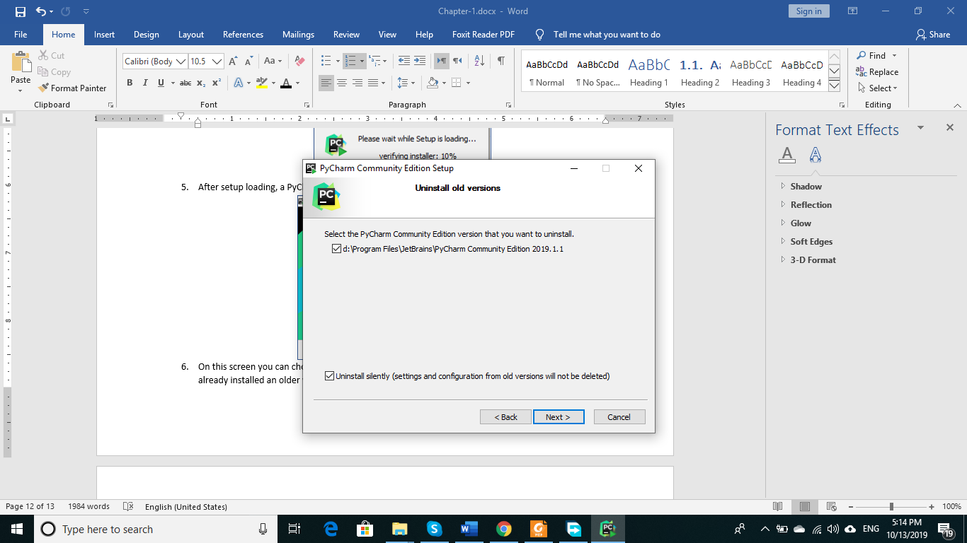

1. From this screen, you can choose the path of installation and click on next

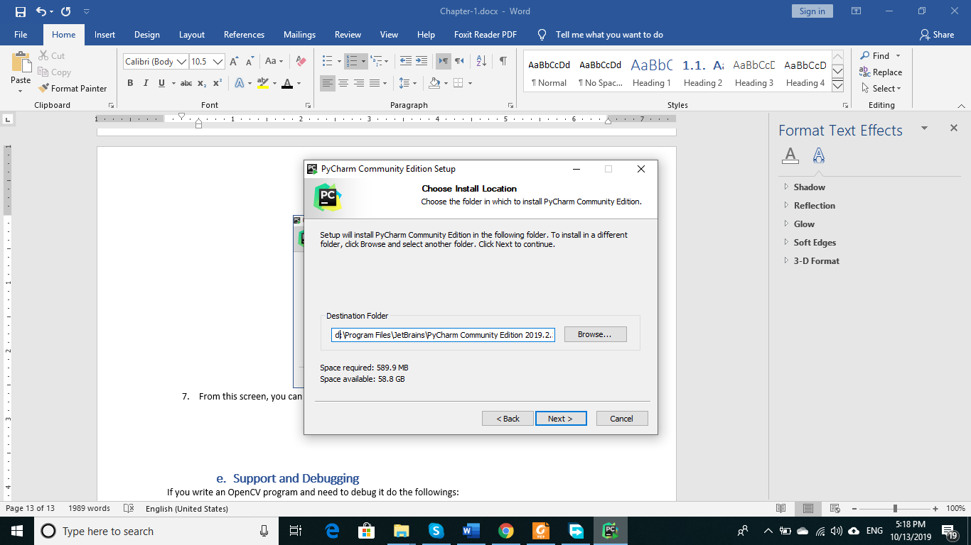

1. From this screen, you have to select few options as shown

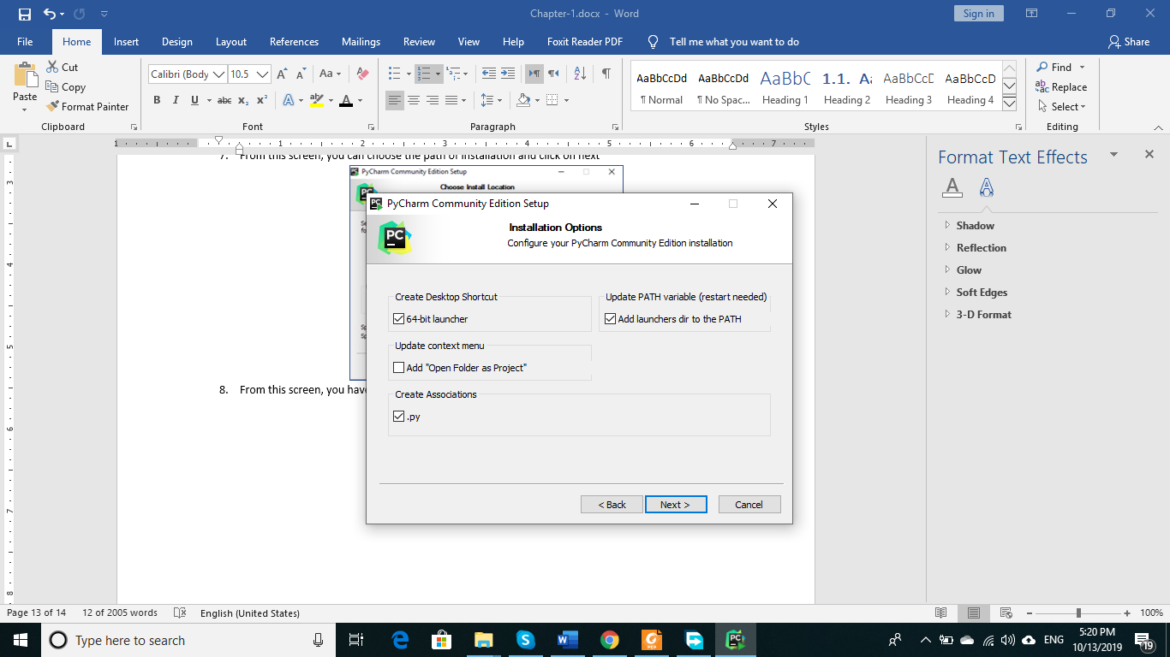

1. This screen shows that what name should be given to main menu entry for this software. We leave it as it is and press on “Install” button

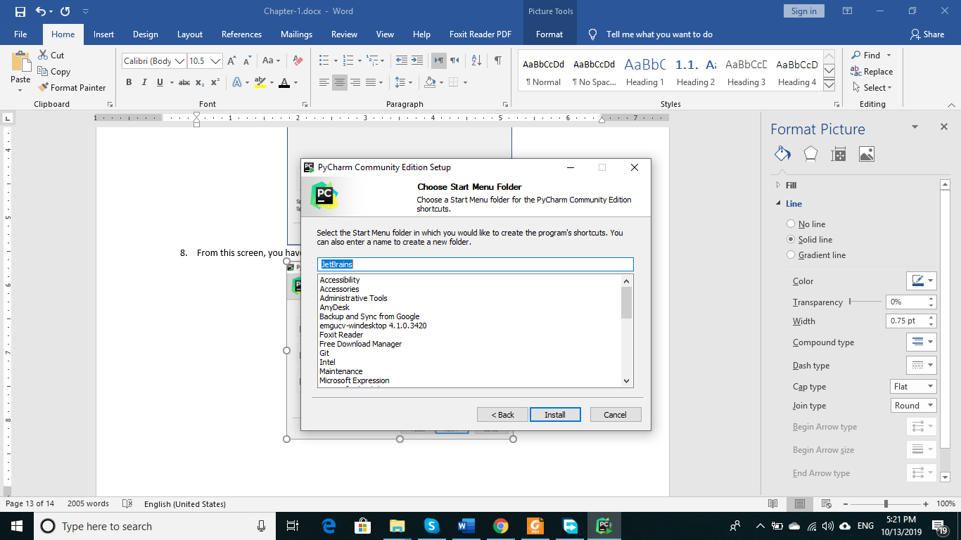

1. This will start installing the software

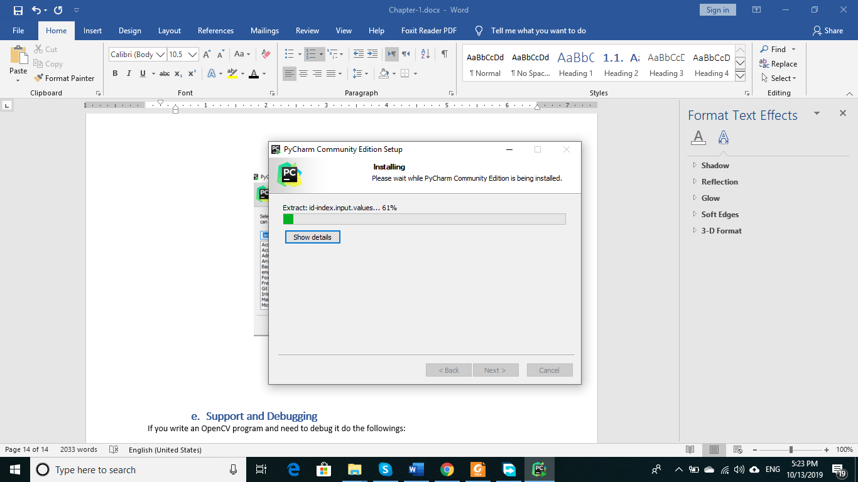

After installation completion, the setup will ask for system reboot. Reboot the system by clicking the button

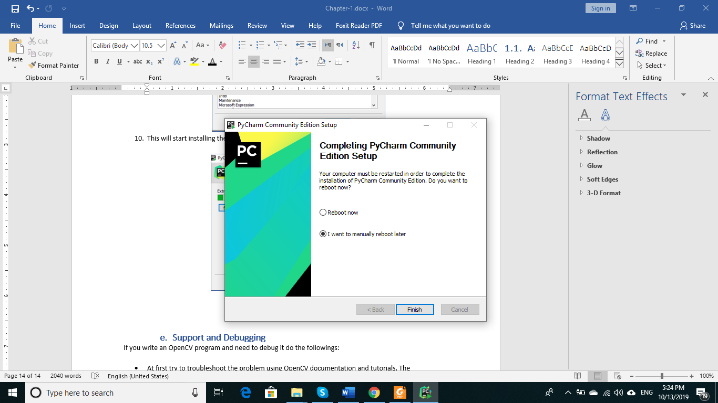

The installation is complete. To run the IDE, when you click its icon to run it, you may get this dialogue box.

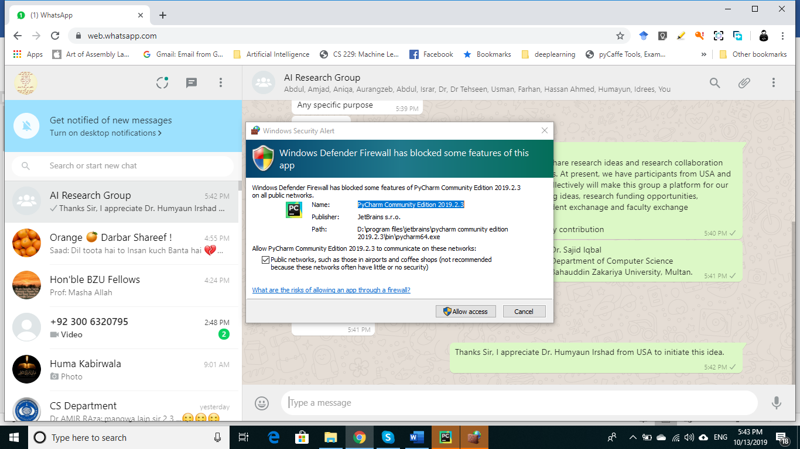

When you first time start PyCharm IDE, you are welcomed with following dialogue box:

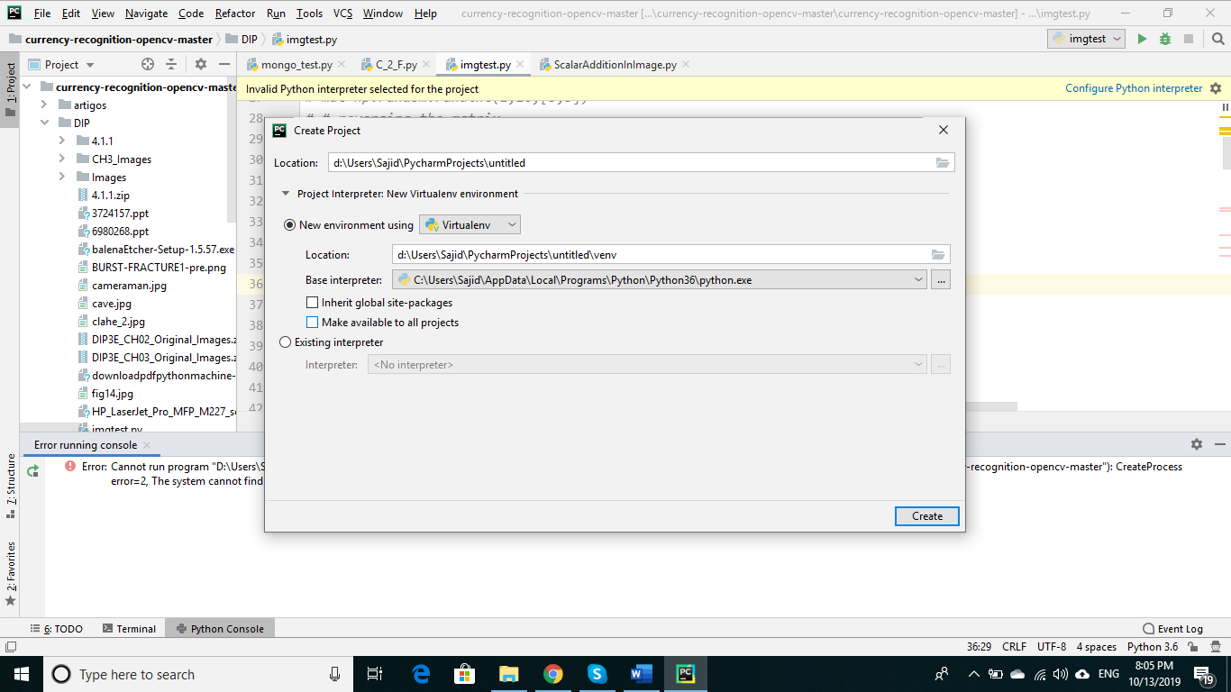

In this dialogue box, you specify the project name, location of your project and “Base Interpreter”. If you have installed python correctly, you will see here automatically the path where python is installed. In case, you do not see the python path here, either python is not installed correctly or you can browse the path of “python.exe” file. It is important to know that without specifying the python interpreter, you will not be able to run your programs in python. If you have installed everything correctly, click on “Create” button shown in right bottom corner. It will create a “Virtual Environment” for your project.

## Python Virtual Environment

A virtual environment is a tool that helps to keep dependencies required by different projects separate by creating isolated python virtual environments for them. This is one of the most important tools that most of the Python developers use.

Virtual Environment should be used whenever you work on any Python based project. It is generally good to have one new virtual environment for every Python based project you work on. So, the dependencies of every project are isolated from the system and each other.

PyCharm uses a module named $virtualenv$  which is a tool to create isolated Python environments. $virtualenv$ creates a folder which contains all the necessary executables to use the packages that a Python project would need.

It is to note that if you installed some dependencies or libraries in a project that will not be available in new project and you will have to reinstall those.

## Installing other libraries in PyCharm Virtual Environment

There are multiple ways to install libraries in PyCharm that are:

* Online Installation
* Offline installation

### **Online Installation**

You can use PyCharm visual installation method to install libraries. Let we see the case of numpy library.

***Method-1***

Goto $File→Settings$. It will show the following screen:

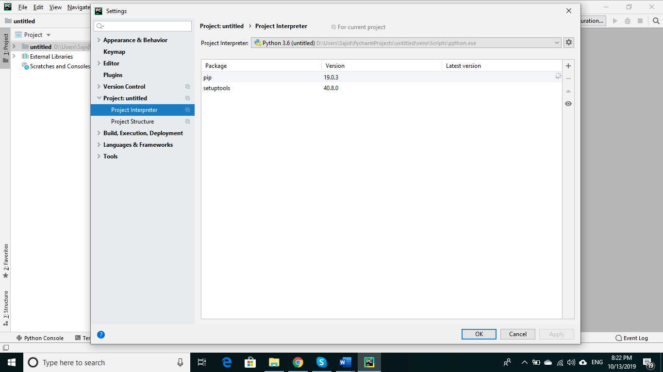

Click on “Project Interpreter”. In above picture, it is showing two packages installed. You can add more packages by clicking on “+” button on right side of dialogue box. This will open another dialogue box titled “Available Packages”. You can select the package of your choice from the list as shown below:

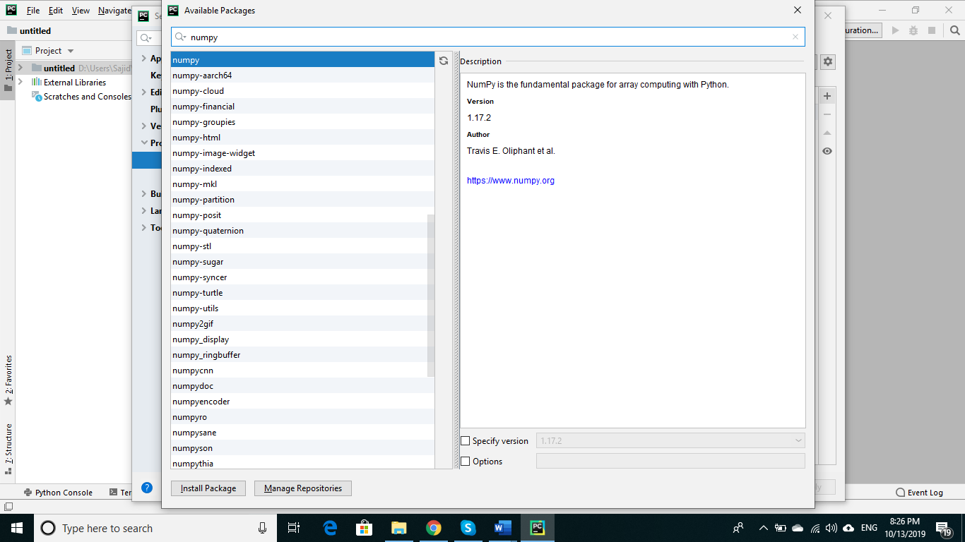

When you type the name of package in text box as shown, the package from list is automatically selected and its newest version is chosen for installation. You can click on “Install Package” to install it. However, if you need to install some specific version, you can also choose the version by selecting “Specify version” option.

***Method-2***

You can give package installation command in “Terminal” window of PyCharm IDE. The Terminal windows can be found at bottom of main IDE windows as shown in following figure

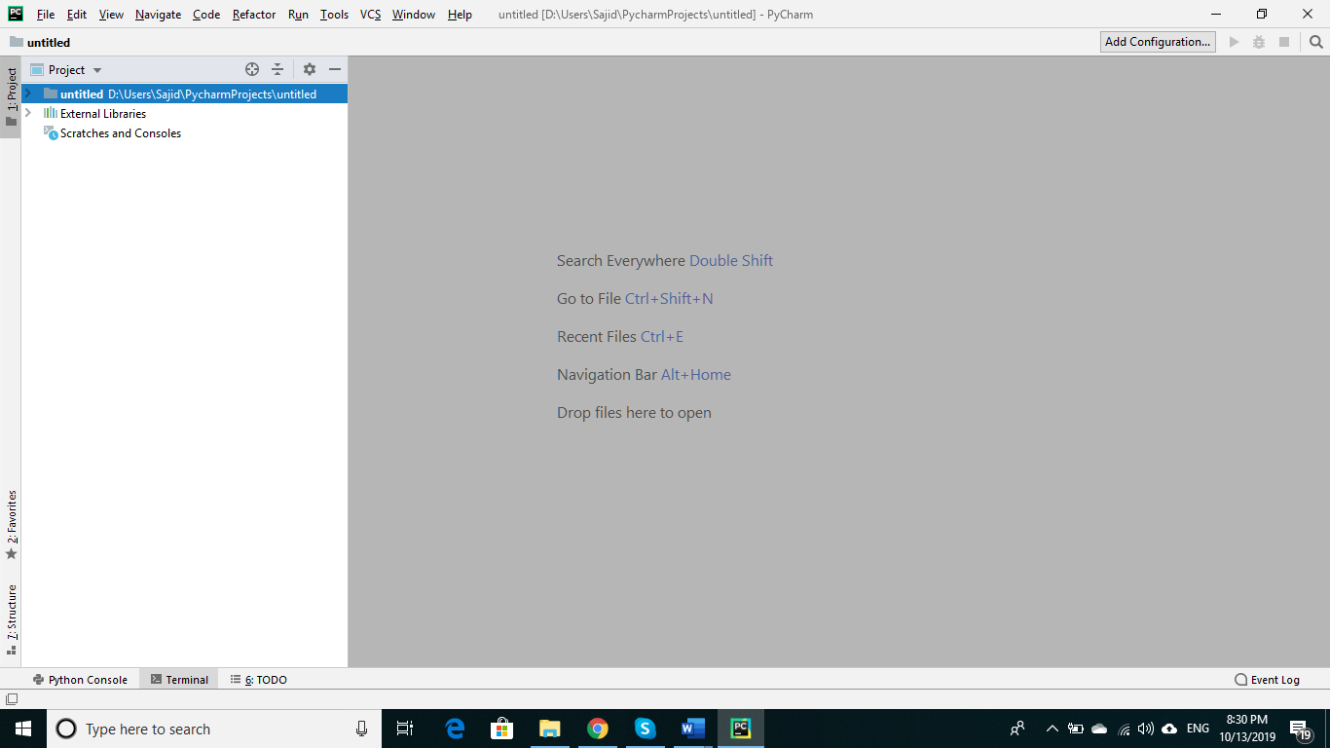

In terminal you can write the python package installation command “pip install numpy” as shown:

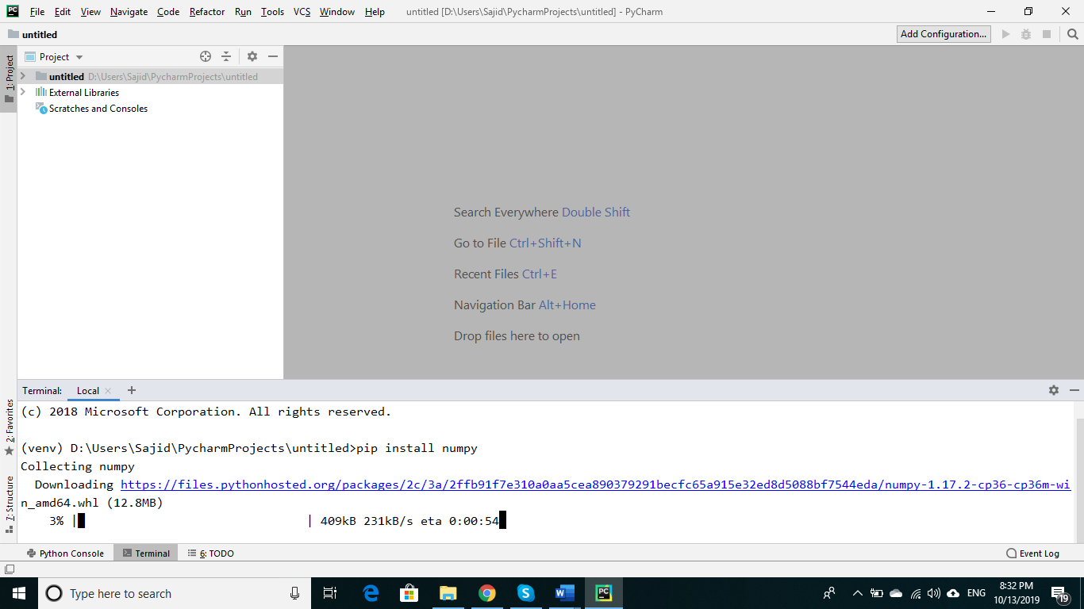

If you are connected with internet, your package installation will start and depending upon your internet speed, it may take some time or even time out. If you get time out error, try to connect with high speed internet connected.

### **Offline Installation**

You can download your python and operating system specific package from python repository. As an example, to install Python wrapper of OpenCV, goto following site:

<https://pypi.org/>

and search for your desired package.

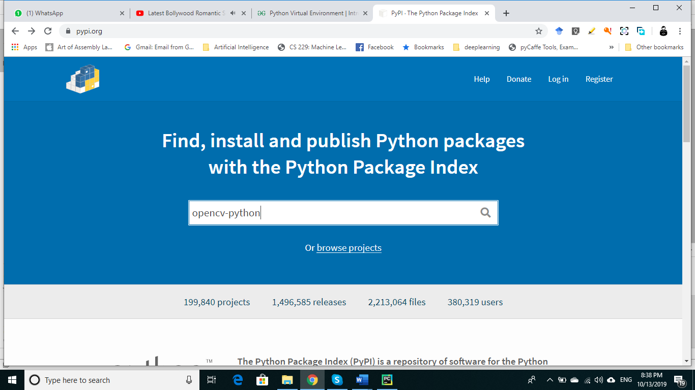

You will get

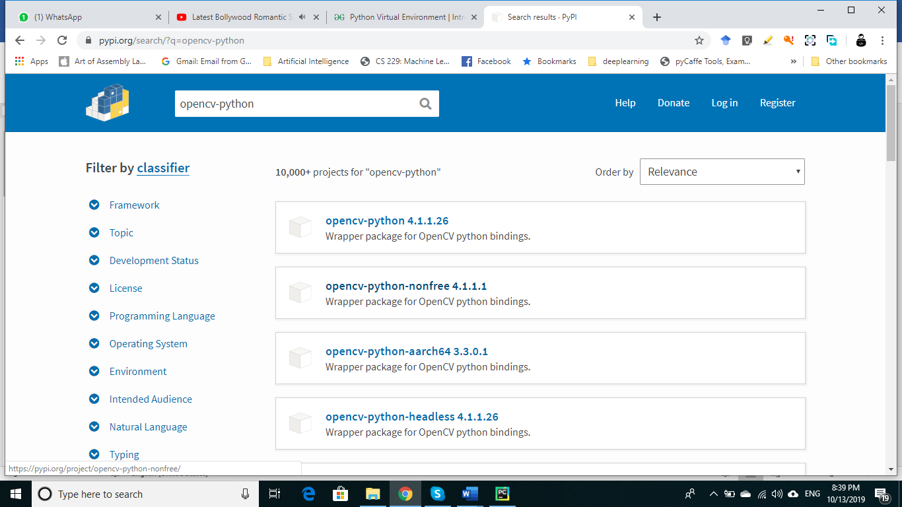

To download the files, click on button “Download files”.

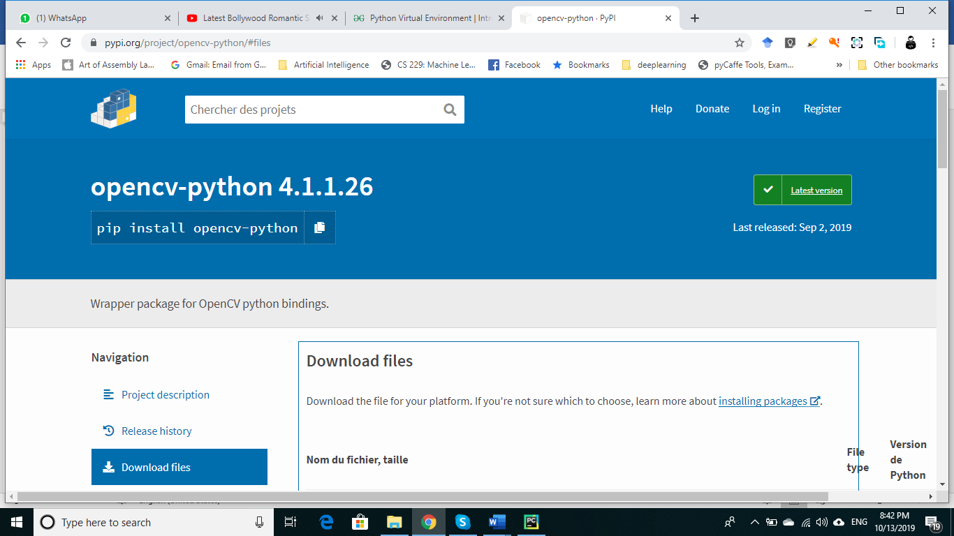

Now select the package you want to download

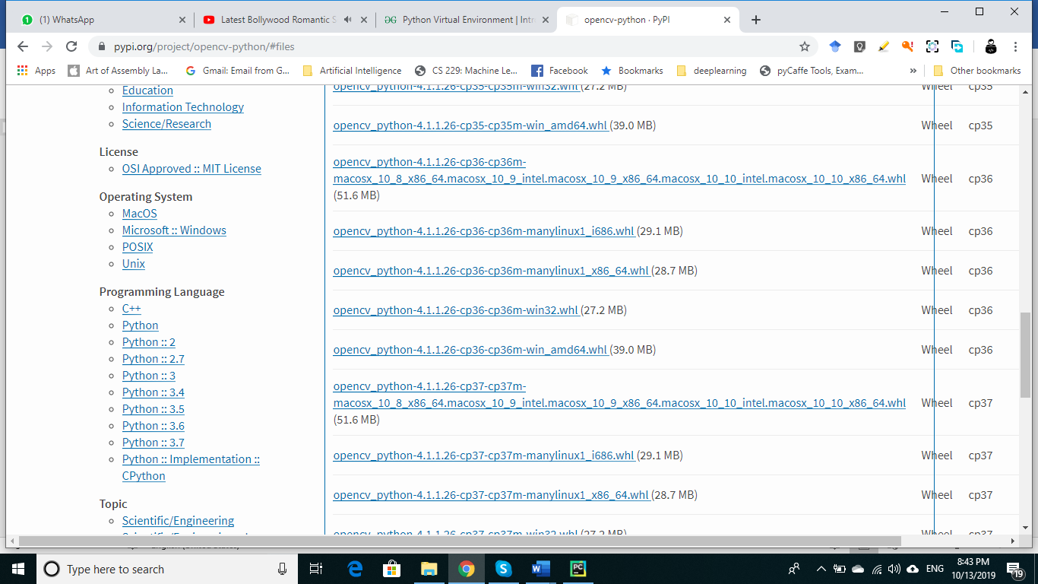

We will select cp36 for python 3.6.x and win_amd64 version for 64-bit windows.

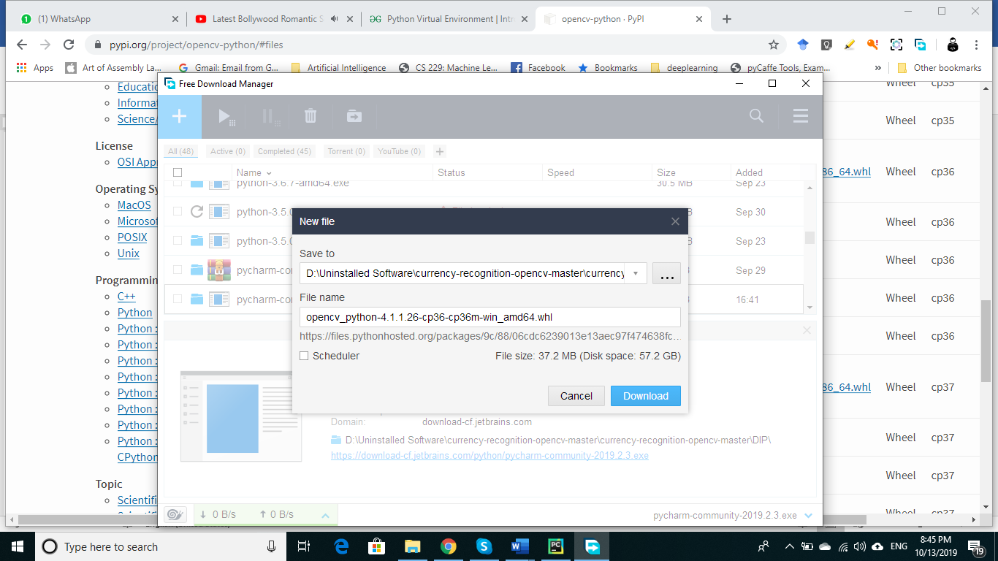

Let we have downloaded the file in the same folder where our python project files will be located so we can install it using following command.

“ $pipinstall{opencv}_{python}−4.1.1.26−cp36−cp36m−{win}_{amd64.whl}$”

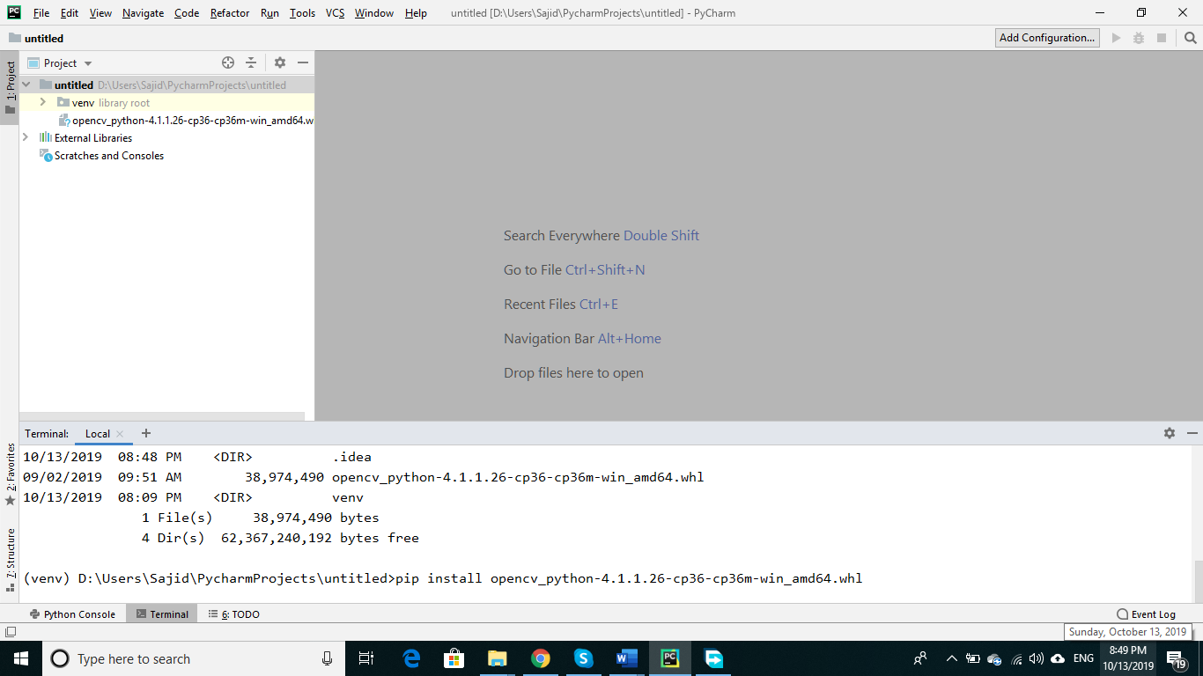

## Writing first Python program

Write click on project name that is “untitled” in our case and choose “ $New→PythonFile$” from popup menu as shown below:

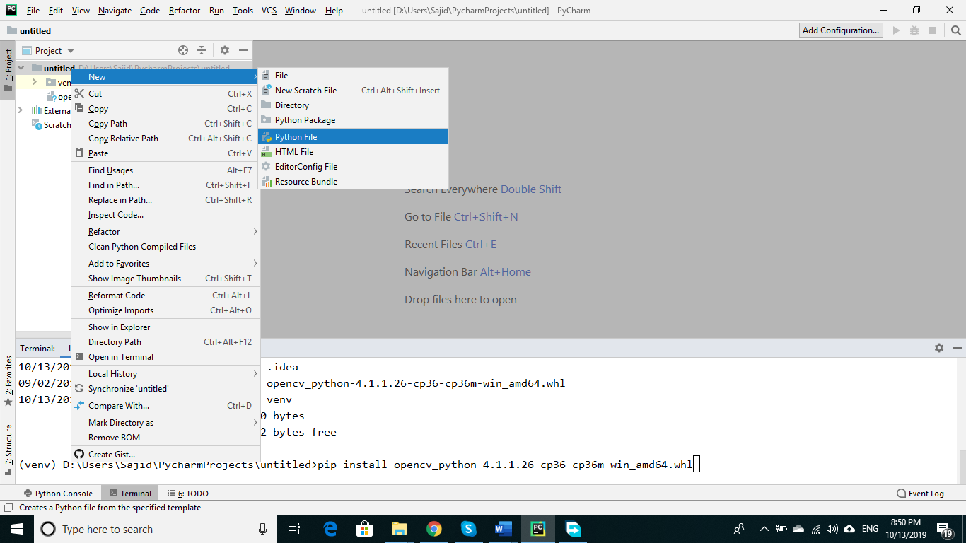

After selecting this, give name of your choice to python file. I have given name “Hello_Python” and press enter.

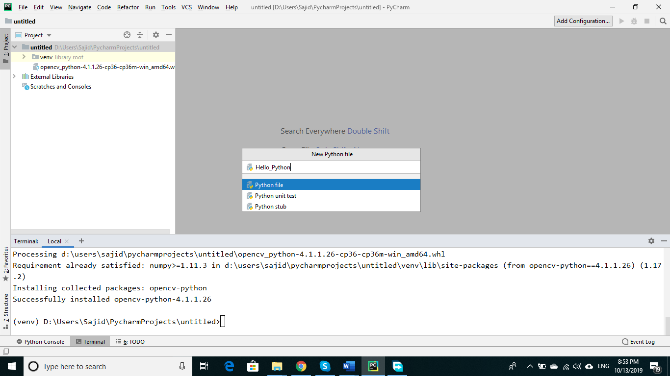

It will create an empty file named “Hello_Python”.

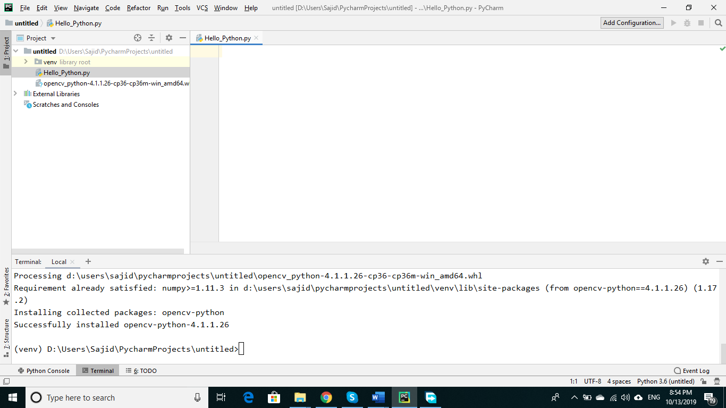

Now you can start writing your code.

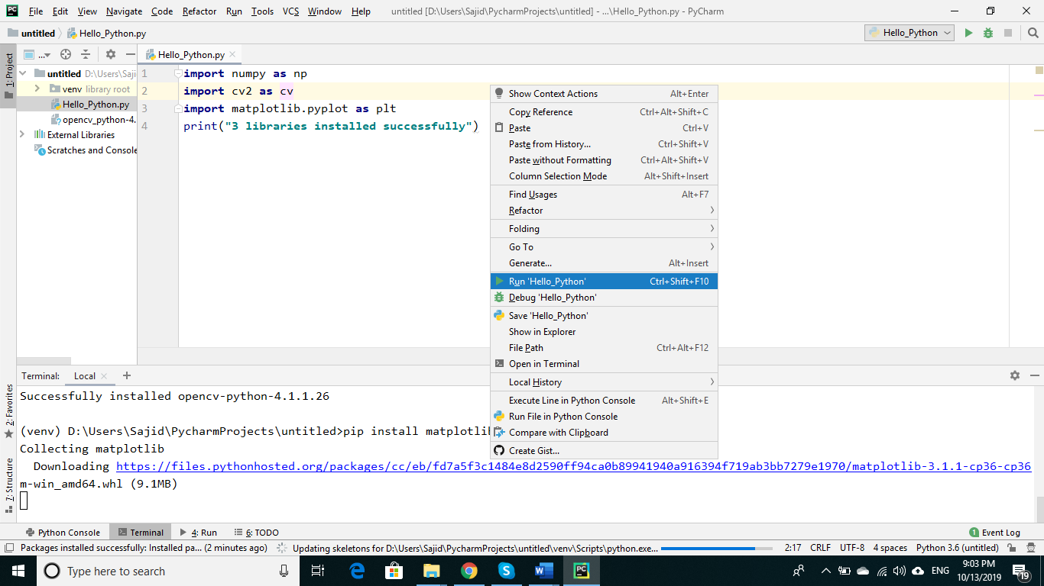

Write above shown code and run the program by write clicking in code window and choosing “Run ‘Hello_Python’” command. If there is no error in your program, you will see following output

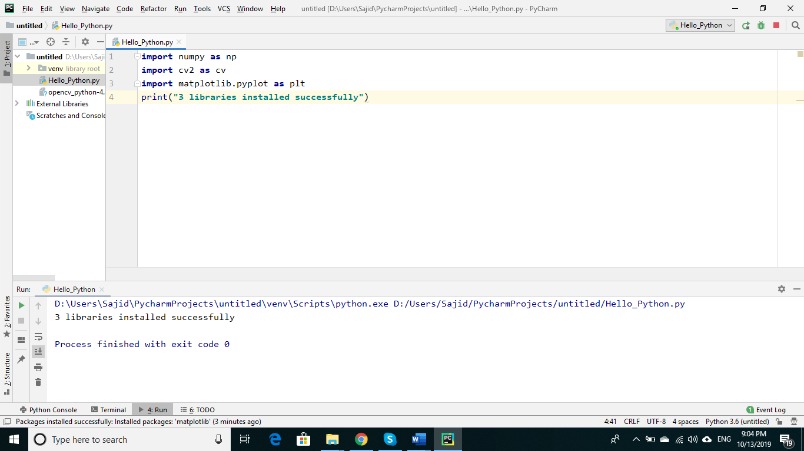

Congratulations, you have installed all required software and wrote your first program. Now go ahead on the ride of wonderful image processing.